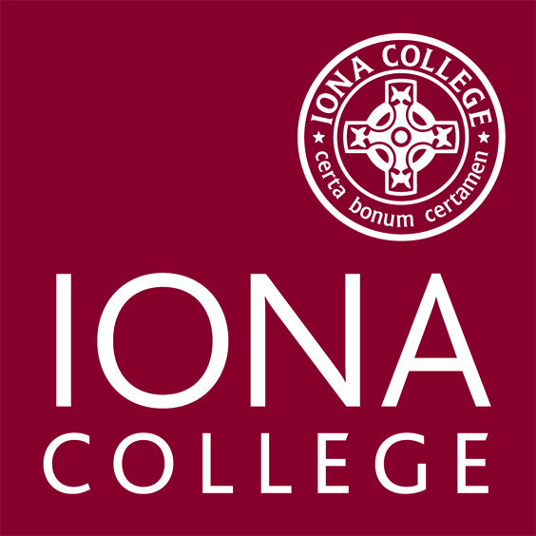

Notice of Acknowledgement of Pay Rate and Payday
Prepared for Non-Exempt Employees - Provided at Time of Hire
Please complete this form & return a signed copy to Human Resources on your First Day of Employment.

Name:
Title:
Department:
Employer Information: | Iona College  715 North Avenue  New Rochelle, NY 10801  914-633-2000
Employee’s pay rate(s): | $ |  | per hour
Regular payday: | Friday
Pay is: | Bi-weekly
Overtime Pay Rate: | $
Allowance(s) taken: | None | Other:
Check all that apply:
I have been given this pay notice in English because it is my primary language.

My primary language is . I have been given this pay notice in English only, because the Department of Labor does not yet offer a pay notice form in my primary language.
While my primary language is , I hereby accept this notification, and all future notifications in English.

Employee Acknowledgement:
On this day I have been notified of my pay rate, applicable allowances, and designated payday on the date given below. I told my employer what my primary language is.

Print Employee Name Preparer’s Name and Title

February 12, 2016
Employee Signature Date

