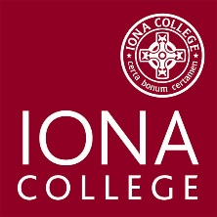

Student New Hire Checklist

Instructions: The hiring department must collect the documentation listed below and securely hand-deliver or send via interoffice mail (Mark envelope “Confidential”) to the Iona College Student Employment Coordinator within 24 hours of receipt. No exceptions.

Name: Start Date:

Employment Authorization Form
I-9
Copies of supporting documentation (e.g. passport picture page)
W4
IT-2104
Direct Deposit (optional)
Confidentiality Form
______ HR Pay Rate Form

Received by: Date:

